1. Create a html file to display the following output: (Credits:1)

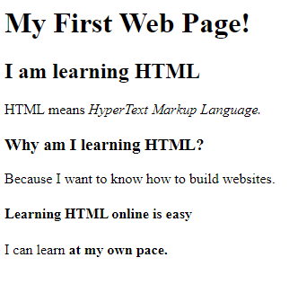

1. Create a html file to display the following output. Please note that the links in the file should redirect to another html page which is designed by you (You have liberty to put any content in those pages). (Credits :1)

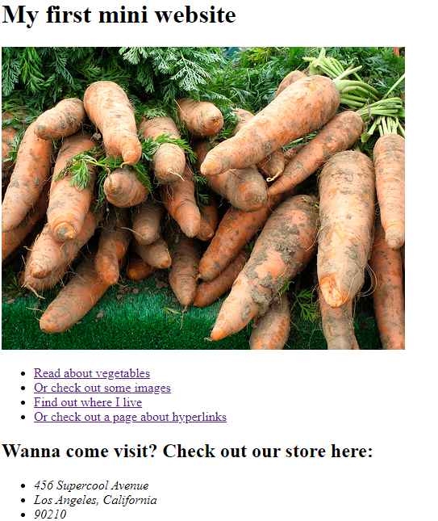

1. Create a paragraph block element. Create at least 5 buttons with different colour names on each button. On clicking each button, the background of the paragraph block element should change to that colour.

Example : When I click on the button with the label “RED” on it, the background colour of the paragraph element should change to red -- (Credits : 2)

1. Design a Like counter button (Credits :1)

Acceptance Criterion 1: Button should have an icon inside it

AC 2: Display the counter value in a presentable format.

AC 3: One button to increment the value.

AC 4: One button to decrement the value.

1. Print the following star program: (Credits : 1)

\*

\*\*

\*\*\*

\*\*\*\*

\*\*\*\*\*

AC 1: on passing a value ‘n’ to the function, n no. of lines should be displayed in the output in the above format

1. Print the following star program: (Credits : 1)

\*

\*\*

\*\*\*

\*\*\*\*

\*\*\*\*\*

AC 1: on passing a value ‘n’ to the function, n no. of lines should be displayed in the output in the above format

1. Design a calculator program (Credits : 3)

AC1 : calculator should have all basic operations. (+,-,\*,/)

AC2: Calculator should have 3 input boxes, 1 input to get first operand, 2nd input to get operator, 3rd input to get second operand.

AC3: On clicking the “=” button, the answer should get displayed in a separate text element in bold.

NOTE: Please feel free to use google to learn the concepts but not copy the code to submit the assignment. It is easy to detect plagiarism in the assignments submitted.